**Problem Statement I – State Diagram**

A simple digital watch has a display and two buttons to set it, the A button and the B button. The watch has two modes of operation, display time and set time.

In the display time mode, hours and minutes are displayed. The set time mode has two sub modes: set hours and set minutes. The A button is used to select modes. Each time it is pressed, it advances through the modes: display, set hours, set minutes, display ...etc. Within the sub modes, pressing B will advance the hours or minutes each time it is pressed. Buttons must be released before they generate another event.

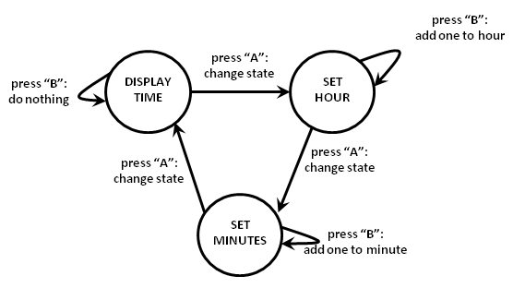

|  |  |  |  |
| --- | --- | --- | --- |
|  | **Display-times** | **Set-hours** | **Set-minutes** |
| **Display-times (s1)** | Press B (e1) | Press A (e2) | - |
| **Set-hours (s2)** | - | Press B (e1) | Press A (e2) |
| **Set-minutes (s3)** | Press A (e2) | - | Press B (e1) |

Test Suite

|  |  |  |  |
| --- | --- | --- | --- |
| Test Cases | #1 | #2 | #3 |
| S1 | E1 | E2 | S1 |
| S2 | E1 | E2 | S2 |
| S3 | E2 | E1 | S3 |

**Problem Statement II –Activity Diagram**

As a consultant, you are asked to design a class that handles login and security for an application. The basic functions of the class are:

* + The user must first enter a valid login name. The system checks to see that the name is valid before asking for a password. If it is not valid, the user can either exit (cancel) or re-enter the name.
  + The user then must enter the password associated with the name. The system validates that the password is the appropriate one for the login name. If the password is invalid, the user can cancel and exit, re-enter the password, or go back to the first step and re-enter the login name.
  + The user selects a function. The system validates that the function is one that the user is allowed to do. If not, the user can either exit, or enter a new function.

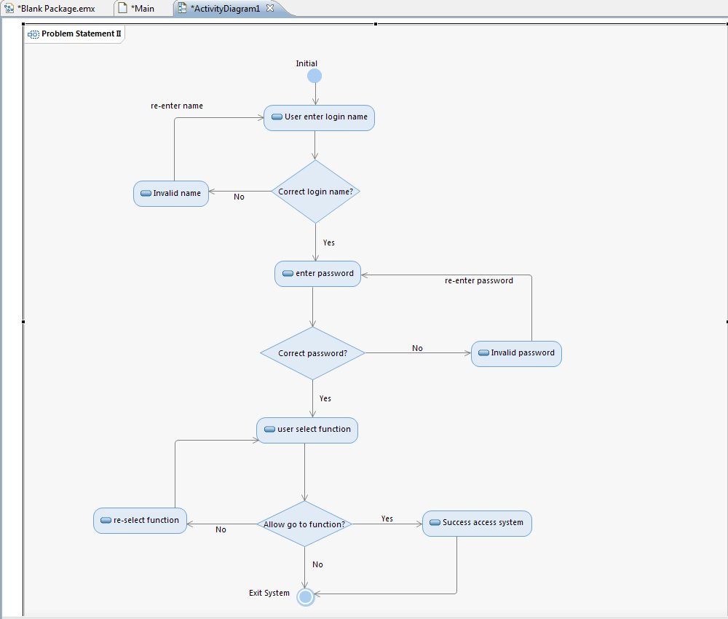

|  |  |  |
| --- | --- | --- |
| Test Cases | Description | Expected Result |
| Name | Enter of login name | Print name is display |
| Password | Enter a password with at least one. The password should not be special character, one number, and     displayed, instead * marks  with a minimum length of 5 character. | displayed, instead * marks   with a minimum length of 5 [character](http://www.geekinterview.com/question_details/42820)  should be displayed |
| Function | Select function after validation name and password | Access function system will display with success name and password |